Imprimer la liste de la page 2 après avoir complété les prénoms des élèves (voir page 3 si le fichier contient 20 fiches).
Découper et coller sur chaque feuille le nom du LOGICO correspondant ci-dessous.
On peut tout imprimer sur A3 si on veut plus de clarté !

Lecture – Fichier 3 | 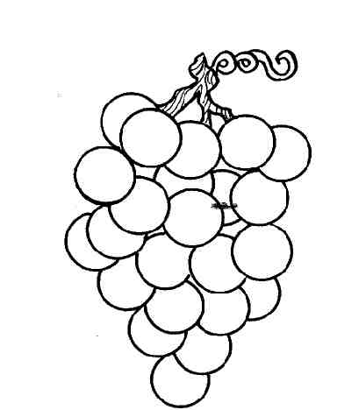 |  | Lecture – Fichier 4 | 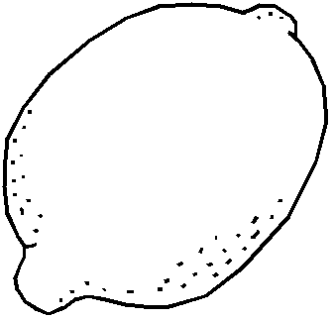

Lecture – Fichier 5 | 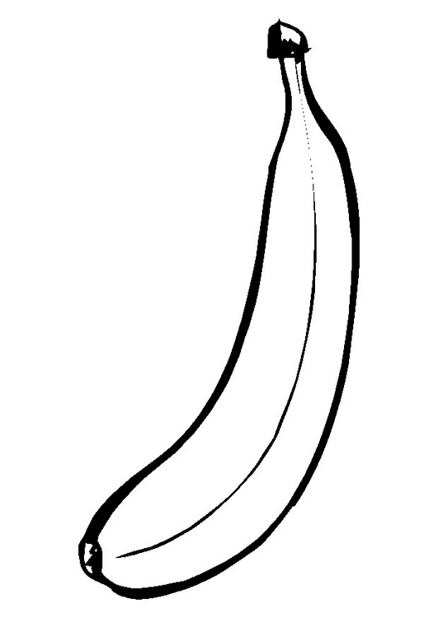 |  | Lecture – Fichier 6 | 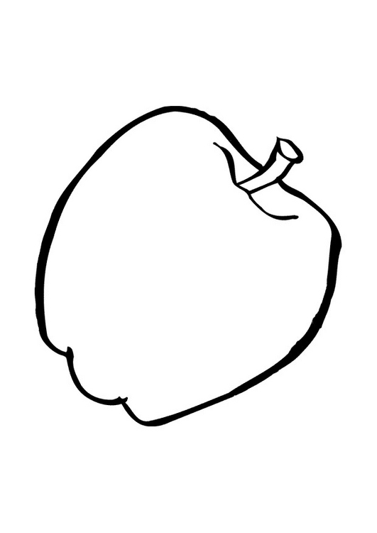

Lecture – Jeux de mots | 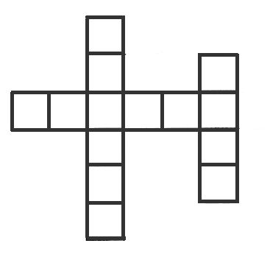

Mathématiques – Fichier 3 | 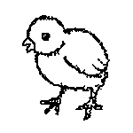 |  | Mathématiques – Fichier 4 | 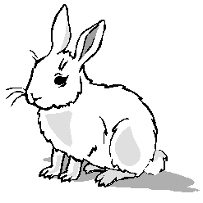

Mathématiques – Fichier 5 | 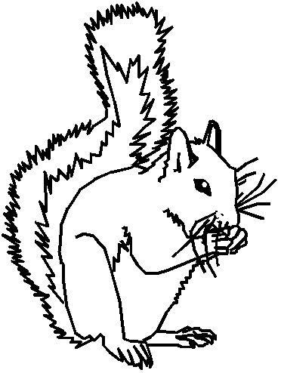 |  | Mathématiques – Fichier 6 | 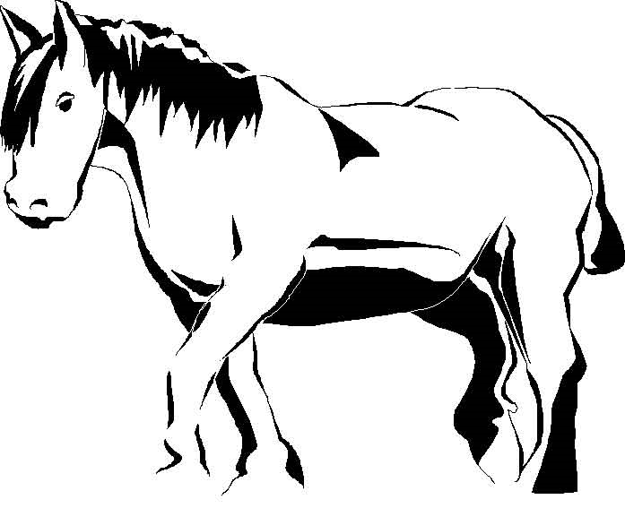

Logique – Cycle 2 | 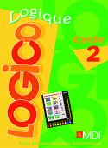

LOGICO – Colorie la case lorsque tu as réussi la fiche. |  |  |  |  |  | coller ici la description correspondante
 | 1 | 2 | 3 | 4 | 5 |  | 6 | 7 | 8 | 9 | 10 | 11 | 12 | 13 | 14 | 15 |  | 16
 | 1 | 2 | 3 | 4 | 5 |  | 6 | 7 | 8 | 9 | 10 | 11 | 12 | 13 | 14 | 15 |  | 16
 | 1 | 2 | 3 | 4 | 5 |  | 6 | 7 | 8 | 9 | 10 | 11 | 12 | 13 | 14 | 15 |  | 16
 | 1 | 2 | 3 | 4 | 5 |  | 6 | 7 | 8 | 9 | 10 | 11 | 12 | 13 | 14 | 15 |  | 16
 | 1 | 2 | 3 | 4 | 5 |  | 6 | 7 | 8 | 9 | 10 | 11 | 12 | 13 | 14 | 15 |  | 16
 | 1 | 2 | 3 | 4 | 5 |  | 6 | 7 | 8 | 9 | 10 | 11 | 12 | 13 | 14 | 15 |  | 16
 | 1 | 2 | 3 | 4 | 5 |  | 6 | 7 | 8 | 9 | 10 | 11 | 12 | 13 | 14 | 15 |  | 16
 | 1 | 2 | 3 | 4 | 5 |  | 6 | 7 | 8 | 9 | 10 | 11 | 12 | 13 | 14 | 15 |  | 16
 | 1 | 2 | 3 | 4 | 5 |  | 6 | 7 | 8 | 9 | 10 | 11 | 12 | 13 | 14 | 15 |  | 16
 | 1 | 2 | 3 | 4 | 5 |  | 6 | 7 | 8 | 9 | 10 | 11 | 12 | 13 | 14 | 15 |  | 16
 | 1 | 2 | 3 | 4 | 5 |  | 6 | 7 | 8 | 9 | 10 | 11 | 12 | 13 | 14 | 15 |  | 16
 | 1 | 2 | 3 | 4 | 5 |  | 6 | 7 | 8 | 9 | 10 | 11 | 12 | 13 | 14 | 15 |  | 16
 | 1 | 2 | 3 | 4 | 5 |  | 6 | 7 | 8 | 9 | 10 | 11 | 12 | 13 | 14 | 15 |  | 16
 | 1 | 2 | 3 | 4 | 5 |  | 6 | 7 | 8 | 9 | 10 | 11 | 12 | 13 | 14 | 15 |  | 16
 | 1 | 2 | 3 | 4 | 5 |  | 6 | 7 | 8 | 9 | 10 | 11 | 12 | 13 | 14 | 15 |  | 16
 | 1 | 2 | 3 | 4 | 5 |  | 6 | 7 | 8 | 9 | 10 | 11 | 12 | 13 | 14 | 15 |  | 16
 | 1 | 2 | 3 | 4 | 5 |  | 6 | 7 | 8 | 9 | 10 | 11 | 12 | 13 | 14 | 15 |  | 16
 | 1 | 2 | 3 | 4 | 5 |  | 6 | 7 | 8 | 9 | 10 | 11 | 12 | 13 | 14 | 15 |  | 16
 | 1 | 2 | 3 | 4 | 5 |  | 6 | 7 | 8 | 9 | 10 | 11 | 12 | 13 | 14 | 15 |  | 16
 | 1 | 2 | 3 | 4 | 5 |  | 6 | 7 | 8 | 9 | 10 | 11 | 12 | 13 | 14 | 15 |  | 16
 | 1 | 2 | 3 | 4 | 5 |  | 6 | 7 | 8 | 9 | 10 | 11 | 12 | 13 | 14 | 15 |  | 16
 | 1 | 2 | 3 | 4 | 5 |  | 6 | 7 | 8 | 9 | 10 | 11 | 12 | 13 | 14 | 15 |  | 16
 | 1 | 2 | 3 | 4 | 5 |  | 6 | 7 | 8 | 9 | 10 | 11 | 12 | 13 | 14 | 15 |  | 16
 | 1 | 2 | 3 | 4 | 5 |  | 6 | 7 | 8 | 9 | 10 | 11 | 12 | 13 | 14 | 15 |  | 16

LOGICO – Colorie la case lorsque tu as réussi la fiche. |  |  |  |  |  |  |  | coller ici la description correspondante
 | 1 | 2 | 3 | 4 | 5 | 6 | 7 |  | 8 | 9 | 10 | 11 | 12 | 13 | 14 | 15 | 16 | 17 | 18 |  | 19 | 20
 | 1 | 2 | 3 | 4 | 5 | 6 | 7 |  | 8 | 9 | 10 | 11 | 12 | 13 | 14 | 15 | 16 | 17 | 18 |  | 19 | 20
 | 1 | 2 | 3 | 4 | 5 | 6 | 7 |  | 8 | 9 | 10 | 11 | 12 | 13 | 14 | 15 | 16 | 17 | 18 |  | 19 | 20
 | 1 | 2 | 3 | 4 | 5 | 6 | 7 |  | 8 | 9 | 10 | 11 | 12 | 13 | 14 | 15 | 16 | 17 | 18 |  | 19 | 20
 | 1 | 2 | 3 | 4 | 5 | 6 | 7 |  | 8 | 9 | 10 | 11 | 12 | 13 | 14 | 15 | 16 | 17 | 18 |  | 19 | 20
 | 1 | 2 | 3 | 4 | 5 | 6 | 7 |  | 8 | 9 | 10 | 11 | 12 | 13 | 14 | 15 | 16 | 17 | 18 |  | 19 | 20
 | 1 | 2 | 3 | 4 | 5 | 6 | 7 |  | 8 | 9 | 10 | 11 | 12 | 13 | 14 | 15 | 16 | 17 | 18 |  | 19 | 20
 | 1 | 2 | 3 | 4 | 5 | 6 | 7 |  | 8 | 9 | 10 | 11 | 12 | 13 | 14 | 15 | 16 | 17 | 18 |  | 19 | 20
 | 1 | 2 | 3 | 4 | 5 | 6 | 7 |  | 8 | 9 | 10 | 11 | 12 | 13 | 14 | 15 | 16 | 17 | 18 |  | 19 | 20
 | 1 | 2 | 3 | 4 | 5 | 6 | 7 |  | 8 | 9 | 10 | 11 | 12 | 13 | 14 | 15 | 16 | 17 | 18 |  | 19 | 20
 | 1 | 2 | 3 | 4 | 5 | 6 | 7 |  | 8 | 9 | 10 | 11 | 12 | 13 | 14 | 15 | 16 | 17 | 18 |  | 19 | 20
 | 1 | 2 | 3 | 4 | 5 | 6 | 7 |  | 8 | 9 | 10 | 11 | 12 | 13 | 14 | 15 | 16 | 17 | 18 |  | 19 | 20
 | 1 | 2 | 3 | 4 | 5 | 6 | 7 |  | 8 | 9 | 10 | 11 | 12 | 13 | 14 | 15 | 16 | 17 | 18 |  | 19 | 20
 | 1 | 2 | 3 | 4 | 5 | 6 | 7 |  | 8 | 9 | 10 | 11 | 12 | 13 | 14 | 15 | 16 | 17 | 18 |  | 19 | 20
 | 1 | 2 | 3 | 4 | 5 | 6 | 7 |  | 8 | 9 | 10 | 11 | 12 | 13 | 14 | 15 | 16 | 17 | 18 |  | 19 | 20
 | 1 | 2 | 3 | 4 | 5 | 6 | 7 |  | 8 | 9 | 10 | 11 | 12 | 13 | 14 | 15 | 16 | 17 | 18 |  | 19 | 20
 | 1 | 2 | 3 | 4 | 5 | 6 | 7 |  | 8 | 9 | 10 | 11 | 12 | 13 | 14 | 15 | 16 | 17 | 18 |  | 19 | 20
 | 1 | 2 | 3 | 4 | 5 | 6 | 7 |  | 8 | 9 | 10 | 11 | 12 | 13 | 14 | 15 | 16 | 17 | 18 |  | 19 | 20
 | 1 | 2 | 3 | 4 | 5 | 6 | 7 |  | 8 | 9 | 10 | 11 | 12 | 13 | 14 | 15 | 16 | 17 | 18 |  | 19 | 20
 | 1 | 2 | 3 | 4 | 5 | 6 | 7 |  | 8 | 9 | 10 | 11 | 12 | 13 | 14 | 15 | 16 | 17 | 18 |  | 19 | 20
 | 1 | 2 | 3 | 4 | 5 | 6 | 7 |  | 8 | 9 | 10 | 11 | 12 | 13 | 14 | 15 | 16 | 17 | 18 |  | 19 | 20
 | 1 | 2 | 3 | 4 | 5 | 6 | 7 |  | 8 | 9 | 10 | 11 | 12 | 13 | 14 | 15 | 16 | 17 | 18 |  | 19 | 20
 | 1 | 2 | 3 | 4 | 5 | 6 | 7 |  | 8 | 9 | 10 | 11 | 12 | 13 | 14 | 15 | 16 | 17 | 18 |  | 19 | 20
 | 1 | 2 | 3 | 4 | 5 | 6 | 7 |  | 8 | 9 | 10 | 11 | 12 | 13 | 14 | 15 | 16 | 17 | 18 |  | 19 | 20

